**EXPT NO : 5 A python program to implement Multi Layer**

**Perceptron With Backpropagation**

**DATE: 20.9.24**

**AIM:**

To write a python program to implement Multilayer perceptron with backpropagation .

**PROCEDURE:**

Implementing Multilayer perceptron with backpropagation using the Keras dataset involve the following steps:

**Step 1: Import Necessary Libraries**

First, import the libraries that are essential for data manipulation, visualization, and model building.

# importing modules

import tensorflow as tf

import numpy as np

from tensorflow.keras.models import Sequential

from tensorflow.keras.layers import Flatten

from tensorflow.keras.layers import Dense from tensorflow.keras.layers import Activation

import matplotlib.pyplot as plt

**Step 2: Load the Keras Dataset**

The Keras dataset can be loaded.

(x_train, y_train), (x_test, y_test) = tf.keras.datasets.mnist.load_data()

**OUTPUT :**



**Step 3: Data Preprocessing**

Ensure the data is clean and ready for modeling. Since the Iris dataset is clean, minimal preprocessing is needed.

# Cast the records into float values

x_train = x_train.astype('float32')

x_test = x_test.astype('float32')

# normalize image pixel values by dividing

# by 255

gray_scale = 255

x_train /= gray_scale

x_test /= gray_scale

print("Feature matrix:", x_train.shape)

print("Target matrix:", x_test.shape)

print("Feature matrix:", y_train.shape)

print("Target matrix:", y_test.shape)

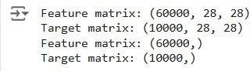**OUTPUT :**

**Step 4 : Train a Model**

**model = Sequential([**

**# reshape 28 row * 28 column data to 28*28 rows Flatten(input_shape=(28, 28)),**

**# dense layer 1**

**Dense(256, activation='sigmoid'),**

**# dense layer 2**

**Dense(128, activation='sigmoid'),**

**# output layer**

**Dense(10, activation='sigmoid'),**

**])**

**OUTPUT:**

**Step 5 : Make Predictions**

Use the model to make predictions based on the independent variable.

model.compile(optimizer='adam',

loss='sparse_categorical_crossentropy', metrics=['accuracy'])

model.fit(x_train, y_train, epochs=10, batch_size=2000,

validation_split=0.2)

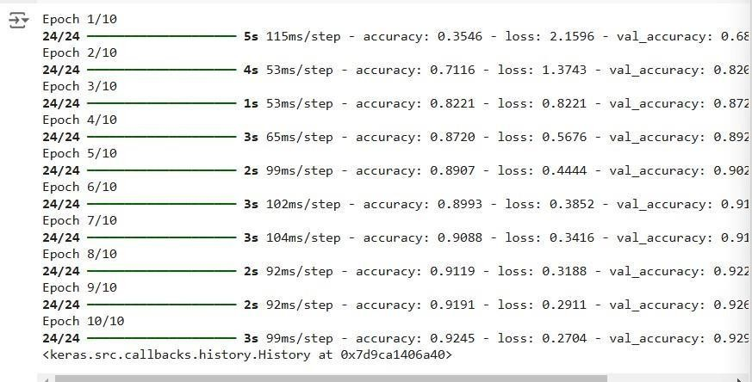**OUTPUT:**

**Step 6 : Evaluate the Model**

Evaluate the model performance.

|  |
| --- |
| results = model.evaluate(x_test, y_test, verbose = 0) |
| print('test loss, test acc:', results) |
| fig, ax = plt.subplots(10, 10) |
| k = 0 |

|  |
| --- |
| for i in range(10): |
| for j in range(10): ax[i][j].imshow(x_train[k].reshape(28, 28),  aspect='auto')  k += 1 plt.show() |

**OUTPUT :**

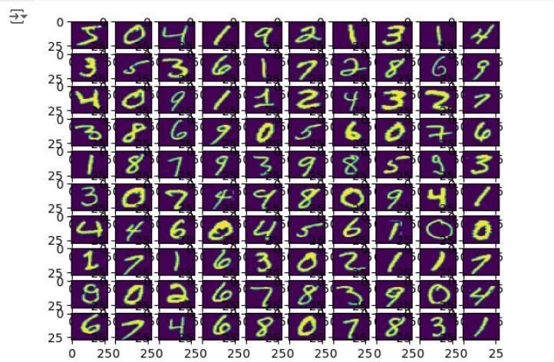

**RESULT:**

This step-by-step process will help us to implement MultiLayer Perceptron with Backpropagation models using the Keras dataset and analyze their performance.